Laurice Sattouf

Choi Tim Anthony Young

Dimitri Garcia

ECE4304- Lab 6

3/24/2021

Professor M. Aly

**Rotate Right and Left Barrel Shifter**

**Introduction:**

Figure (1) show the schematic for a barrel shifter design without any specific operation. We could perform shift left, shift right, rotate left, rotate right, shift and rotate, left/right, at the same time, all using this combinational design.

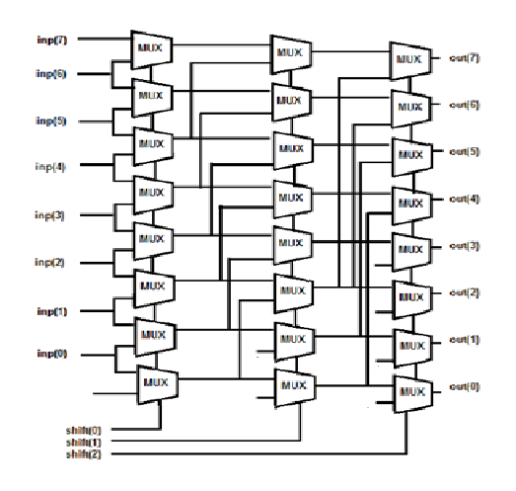

the advantages of barrel shifter is that it could shift multiple bits in a vectors positions at once. In a single pass through the shifter, the inputs can rotate from 0 to 7 positions (for 8bits inputs). The control inputs specify the number of positions to shift the inputs.

**Purpose:**

1. Design a Barrel shifter that allows rotating right and left on an eight-bits input.
2. Assign control inputs to decide the amount of rotate needed.
3. Assign control input to decide the direction of rotation, left or right.
4. Make the following specification for the display:
   1. 2 digits for the inputs.
   2. 2 digits for the outputs.
   3. 1 digit for control.
5. All possible corner cases should be defined using a testbench textio.

**Procedure:**

The following components were created:

1. Mux entity as a basic component.

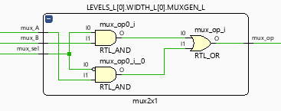

1. Generic barrel shift component.

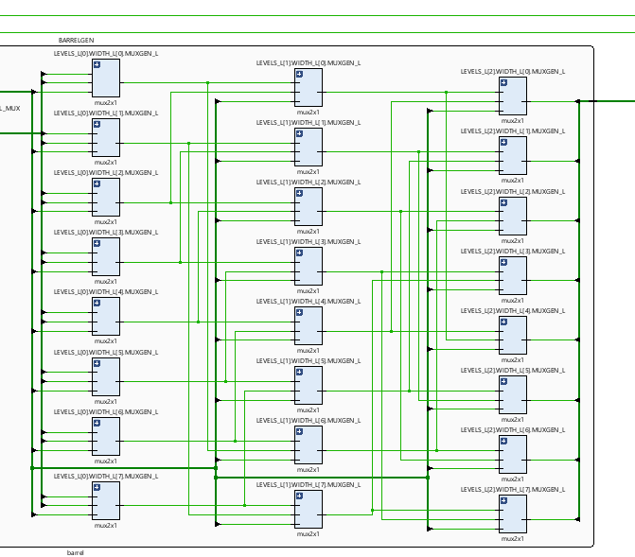

1. 7segment unit.

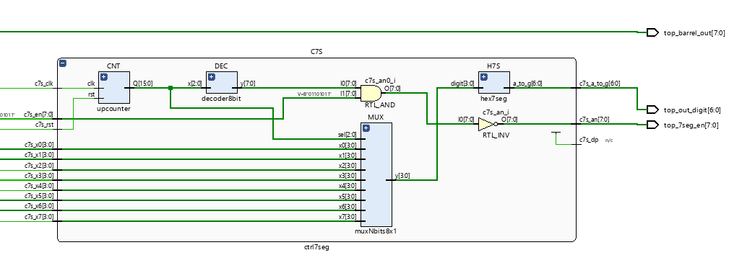

1. Top unit to wrap all the units and implement the required design.

**Schematic:**

Wrapping all the component created, we end up having the following design:

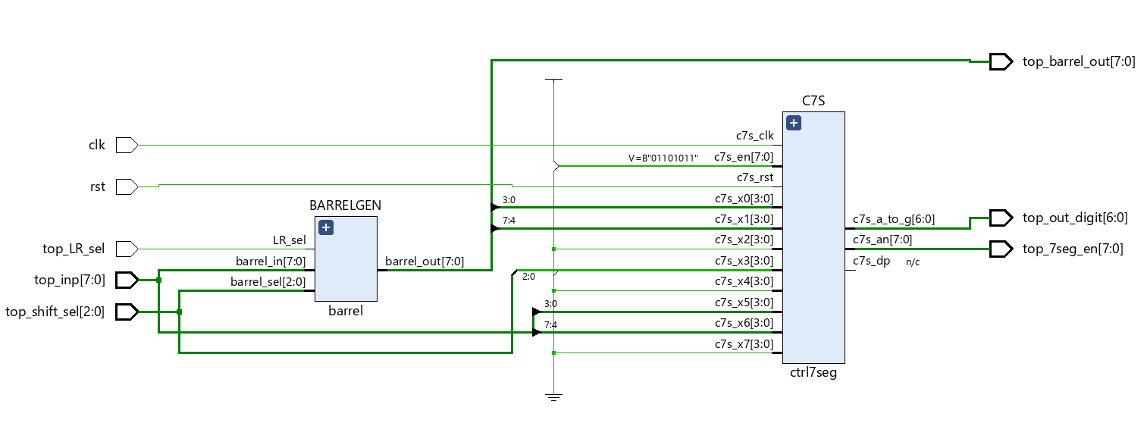

**Power and Resources Used:**



33 lookup tables and 0.126 total power used to implement this design using Vivado.

**Work Contribution:**

* We had a meeting to brainstorm and explain the main idea of the lab, and we created the schematic so that everyone would work individually to achieve the most optimized design.
* We had a zoom meeting to choose the design with less power consuming, then we were able to demo our implemented design and cover all the corner cases.
* Documentation and reports were evenly distributed, and it covered all the steps of our successfully implemented design.